**A**

***PROJECT REPORT***

*on*

**Sweet Byte Delights**

**(Online Bakery Website)**

*Submitted in partial fulfillment of the requirements for the degree of*

**BACHELOR OF TECHNOLOGY**



Session: - May 2024





**A**

***PROJECT REPORT***

*on*

**Sweet Byte Delights**

**(Online Bakery Website)**

*Submitted in partial fulfillment of the requirements for the degree of*

**BACHELOR OF TECHNOLOGY**



**Session: - May 2024**







Department of Computer Science and Engineering

Techno India NJR Institute of Technology, Udaipur-313001

**Certificate**

This is to certify that project work titled **Sweet Byte Delights** by **Garima Parmar** was successfully carried out in the Department of Computer Science and Engineering, TINJRIT and the report is approved for submission in the partial fulfillment of the requirements for award of degree of Bachelor of Technology in Computer Science and Engineering.

Mr. Aaditya Maheswari Dr. Rimpy Bishnoi

Assistant Professor CSE Professor and HOD

Dept. of CSE TINJRIT, Udaipur  Dept. of CSE TINJRIT, Udaipur

Date : Date :



Department of Computer Science and Engineering

Techno India NJR Institute of Technology, Udaipur-313001

**Certificate**

This is to certify that project work titled **Sweet Byte Delights** by **Himanshi Suhalka** was successfully carried out in the Department of Computer Science and Engineering, TINJRIT and the report is approved for submission in the partial fulfillment of the requirements for award of degree of Bachelor of Technology in Computer Science and Engineering.

Mr. Aaditya Maheswari Dr. Rimpy Bishnoi

Assistant Professor CSE Professor and HOD

Dept. of CSE TINJRIT, Udaipur  Dept. of CSE TINJRIT, Udaipur

Date : Date :



Department of Computer Science and Engineering

Techno India NJR Institute of Technology, Udaipur-313001

**Certificate**

This is to certify that project work titled **Sweet Byte Delights** by **Khush Gadhwal** was successfully carried out in the Department of Computer Science and Engineering, TINJRIT and the report is approved for submission in the partial fulfillment of the requirements for award of degree of Bachelor of Technology in Computer Science and Engineering.

Mr. Aaditya Maheswari Dr. Rimpy Bishnoi

Assistant Professor CSE Professor and HOD

Dept. of CSE TINJRIT, Udaipur  Dept. of CSE TINJRIT, Udaipur

Date : Date :



Department of Computer Science and Engineering

Techno India NJR Institute of Technology, Udaipur-313001

**Certificate**

This is to certify that project work titled **Sweet Byte Delights** by **Rohit Tailor** was successfully carried out in the Department of Computer Science and Engineering, TINJRIT and the report is approved for submission in the partial fulfillment of the requirements for award of degree of Bachelor of Technology in Computer Science and Engineering.

Mr. Aaditya Maheswari Dr. Rimpy Bishnoi

Assistant Professor CSE Professor and HOD

Dept. of CSE TINJRIT, Udaipur  Dept. of CSE TINJRIT, Udaipur

Date : Date :



Department of Computer Science and Engineering

Techno India NJR Institute of Technology, Udaipur-313001

**Examiner Certificate**

This is to certify that the following students

**Garima Parmar, Himanshi Suhalka, Khush Gadhwal and Rohit Tailor**

of final year B.Tech. (Computer Science and Engineering), was examined for the project work titled

***Sweet Byte Delights***

during the academic year 2023 – 2024 at Techno India NJR Institute of Technology, Udaipur

**Remarks:**

**Date:**

Signature Signature

(**Internal Examiner**) (**External Examiner**)

Name :- Name :-

Designation:- Designation:-

Department: - Department: -

Organization:- Organization:-

**Preface**

This report presents the culmination of our efforts in designing and developing an online cake delivery website using cutting-edge technologies. The project aimed to create a seamless and intuitive platform for customers to browse, select, and order cakes conveniently from the comfort of their homes. Our focus was not only on functionality but also on delivering a visually appealing user interface (UI) that enhances the overall user experience.

The technologies utilized in this project include Visual Studio 2012 for development and SQL Server 2012 for database management. We leveraged ASP.NET to build the dynamic web pages and integrated SQL Server for efficient data storage and retrieval. These tools enabled us to create an end-to-end solution that meets the demands of modern e-commerce platforms.

Throughout the development process, we prioritized user-centric design principles to ensure that our website is not just functional but also aesthetically pleasing. We conducted rigorous testing and iterations to refine the user interface and optimize performance, resulting in a seamless and responsive web experience.

This report provides a comprehensive overview of the project, including its objectives, scope, methodology, key features, implementation details, challenges encountered, and future enhancements. We extend our gratitude to all those who supported us during this journey, including our mentors, peers, and the resources available to us.

We hope that this report provides valuable insights into the development of online e-commerce platforms and serves as a testament to our dedication to delivering high-quality software solutions.

DEPARTMENT OF COMPUTER SCIENCE AND ENGINEERING

TECHNO INDIA NJR INSTITUTE OF TECHNOLOGY, UDAIPUR-313001

**ACKNOWLEDGMENT**

We take this opportunity to record our sincere thanks to all who helped us to successfully complete this work. Firstly, We are grateful to our **supervisor Aaditya Maheswari** for his invaluable guidance and constant encouragement, support and most importantly for giving us the opportunity to carry out this work.

We would like to express our deepest sense of gratitude and humble regards to our

**Head of Department Dr. Rimpy Bishnoi** for giving invariable encouragement in our endeavors and providing necessary facilities for the same. Also a sincere thanks to all faculty members of CSE, TINJRIT for their help in the project directly or indirectly.

Finally, We would like to thank my friends for their support and discussions that have proved very valuable for us. We are indebted to our parents for providing constant support, love and encouragement. We thank them for the sacrifices they made so that we could grow up in a learning environment. They have always stood by us in everything we have done, providing constant support, encouragement and love.

**Garima Parmar (20ETCCS040)**

**Himanshi Suhalka (20ETCCS051)**

**Khush Gadhwal (20ETCCS062)**

**Rohit Tailor (20ETCCS097)**

DEPARTMENT OF COMPUTER SCIENCE AND ENGINEERING

TECHNO INDIA NJR INSTITUTE OF TECHNOLOGY, UDAIPUR-313001

**Abstract**

This report presents the development of an online cake delivery website using ASP .NET and SQL Server, with a focus on creating a seamless user experience and a visually appealing interface. The project utilized Visual Studio 2012 for development and SQL Server 2012 for database management, alongside ASP.NET for dynamic web page creation. The objective was to build an end-to-end solution that allows customers to browse, select, and order cakes online effortlessly.

Key features of the website include a user-friendly interface, secure payment processing, and efficient order management. The development process involved rigorous testing and iterative improvements to ensure optimal performance and usability. Challenges encountered during development are discussed, along with potential future enhancements to the platform.

This abstract provides a summary of the project's goals, methodology, key features, and outcomes, offering a glimpse into the detailed report that follows.

**CONTENTS**

| **Name of Content** | **Page No.** |
| --- | --- |
| Certificate 1 | III-VI |
| Certificate 2 | VII |
| Preface | VIII |
| Acknowledgement | XI |
| Abstract | X |
| List of Content | XI |
| List of Figurea | XII |
| Chapter 1 Project Overview   * 1. Introduction and Problem Statement   2. Features   3. Technologies and Tools Used      1. ASP .Net      2. SQL      3. Bootstrap      4. Github | 13-23 |
| Chapter 2 Project Implementation  2.1 Planning  2.2 Development Process | 24-30 |
| Chapter 3 User Experience and Challenges  3.1 UI Design  3.2 Navigation & Usability | 31-32 |
| Chapter 4 Challenges & Learnings  4.1 Technological Challenges and Solutions  4.2 Project Learning & Insights | 33-35 |
| Chapter 5 Conclusion & Bibliography | 36-38 |

**LIST OF FIGURES**

| **Figure** | **Page No.** |
| --- | --- |
| Fig 1 Registration Page | 16 |
| Fig 2 Home Page | 17 |
| Fig 3 Category Page | 17 |
| Fig 4 About us Page | 19 |
| Fig 5 Use case Diagram | 25 |
| Fig 6 Workflow of Website | 26 |

**Chapter 1**

**Project Overview**

**Problem Statement**

In today's fast-paced digital age, the integration of technology has become imperative for businesses to stay competitive and meet the evolving demands of consumers. Traditional brick-and-mortar establishments, including bakeries, are increasingly recognizing the need to establish a robust online presence to expand their reach, streamline operations, and enhance customer engagement.

However, many small-scale bakeries face significant challenges in transitioning from traditionalstorefronts to online platforms These challenges include:

1. Limited Reach: Brick-and-mortar bakeries are constrained by geographical boundaries, limiting their potential customer base to local residents and passersby. This restricted reach hampers growth opportunities and revenue generation.
2. Manual Processes: Traditional bakery operations often rely on manual processes for order taking, inventory management, and customer interaction.
3. Lack of Online Presence: Many small-scale bakeries lack an online presence or have outdated and ineffective websites. This absence or inadequacy of online platforms inhibits their ability to attract and retain customers in an increasingly digital marketplace.
4. Limited Customer Engagement: Traditional bakeries struggle to engage with customers beyond the point of sale. Without effective communication channels and interactive platforms, they miss out on opportunities to build relationships, gather feedback, and tailor offerings to customer preferences.

To address these challenges, there is a critical need for innovative solutions that empower small-scale bakeries to establish and manage effective online bakery websites. Such solutions should enable bakeries to showcase their products, facilitate seamless online ordering and payment processes, and foster meaningful engagement with customers.

**Introduction**

**Purpose of the website**:

The online bakery store project aims to provide a convenient and user-friendly platform for customers to browse and order bakery products online.

**Objective of the website:**

* **Establish an Online Presence:** Create a user-friendly platform to showcase and sell bakery products.
* **Increase Sales and Reach:** Expand customer base by leveraging online marketing and accessibility.
* **Enhance Customer Experience:** Provide a seamless and convenient way for customers to browse, order, and receive baked goods.
* **Maintain Quality and Consistency:** Ensure that the online offerings match the quality and standards of in-store products.

**Scope of the website:**

### Frontend Development:

### Website Design: The website will be designed with a focus on aesthetics and usability, employing modern design principles to create an attractive and visually appealing interface. Emphasis will be placed on intuitive navigation, clear layout, and responsive design to ensure an optimal user experience across devices.

* **Product Catalog:** A comprehensive product catalog will be developed to showcase the bakery's offerings. Each product will be presented with high-quality visuals, detailed descriptions, and pricing information to entice and inform customers. The catalog will be organized into categories for easy browsing and searching.
* **User Account Management:** The website will feature user account functionality, allowing customers to create accounts for a personalized shopping experience. Registered users will have access to features such as order history, saved preferences, and address management. The account creation process will be streamlined and user-friendly to encourage adoption.
* **Shopping Cart and Checkout:** A robust shopping cart and checkout system will be implemented to facilitate smooth and secure transactions. Customers will be able to add products to their cart, review their selections, and proceed to checkout seamlessly. Multiple payment options will be supported, including credit/debit cards, digital wallets, and cash on delivery.

1. **Backend Development:**

* **Order Management:** A backend order management system will be developed to streamline the processing and tracking of orders. This system will handle order placement, order fulfillment, inventory management, and order status updates. Admins will have access to a dashboard where they can view, manage, and fulfill orders efficiently.
* **Significance**: The website addresses the growing demand for online shopping and personalized bakery items by providing a digital storefront for the bakery business. By offering a convenient and accessible platform for customers to browse, order, and receive bakery products, the website enhances the bakery's reach and competitiveness in the digital marketplace.
* **Target Audience**: The target audience for the website includes individuals who prefer the convenience and flexibility of online shopping for bakery products. This includes customers looking for a wide range of bakery items, including cakes, pastries, desserts, and customized orders for special occasions such as birthdays, weddings, and celebrations. The website caters to both local customers and those seeking unique and personalized bakery creations.

**Features**

1. **Login / Register:**

* Users can create an account or log in using their credentials.
* Additional features may include password recovery, email verification, and social media login options for user convenience.

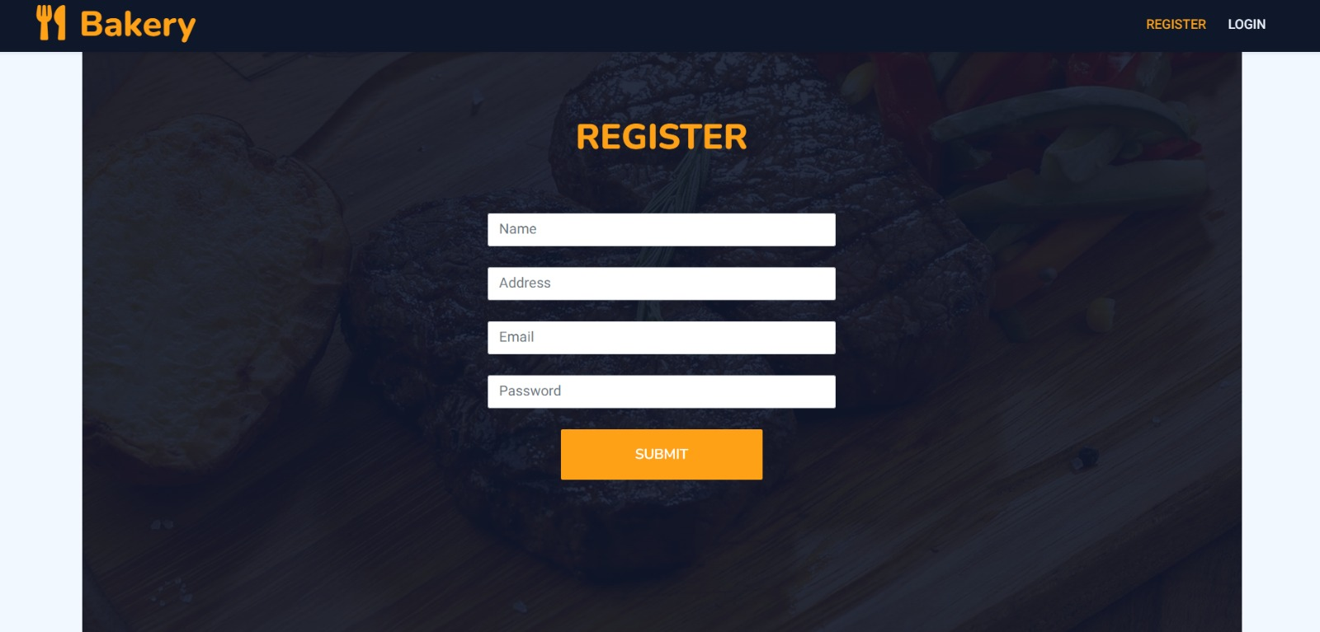

*Figure 1 Registration Page*

1. **Admin and User Sections:**

* Admin have access to backend functionalities such as managing orders, products, user accounts, and generating reports.
* Regular users can browse products, add items to the cart, place orders, track deliveries, and leave reviews.

1. **Home:**

* The homepage features a visually appealing layout with sliders showcasing featured products, promotions, and special offers.
* Quick links and call-to-action buttons direct users to key sections like the menu, services, and promotions.

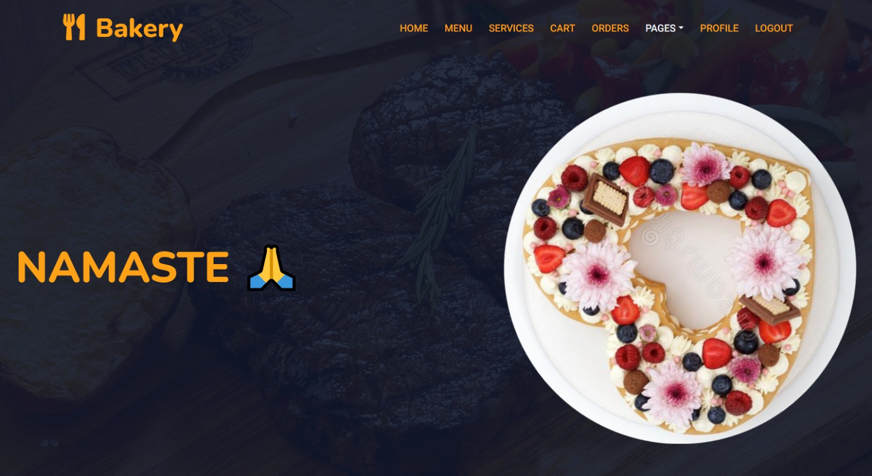

*Figure 2 Home Page*

1. **Menu:**

* Products are categorized logically (e.g., cakes, pastries, bread, beverages) with detailed descriptions, images, and prices.
* Filtering options based on dietary preferences (e.g., gluten-free, vegan) or occasion (e.g., birthdays, weddings) enhance user experience.

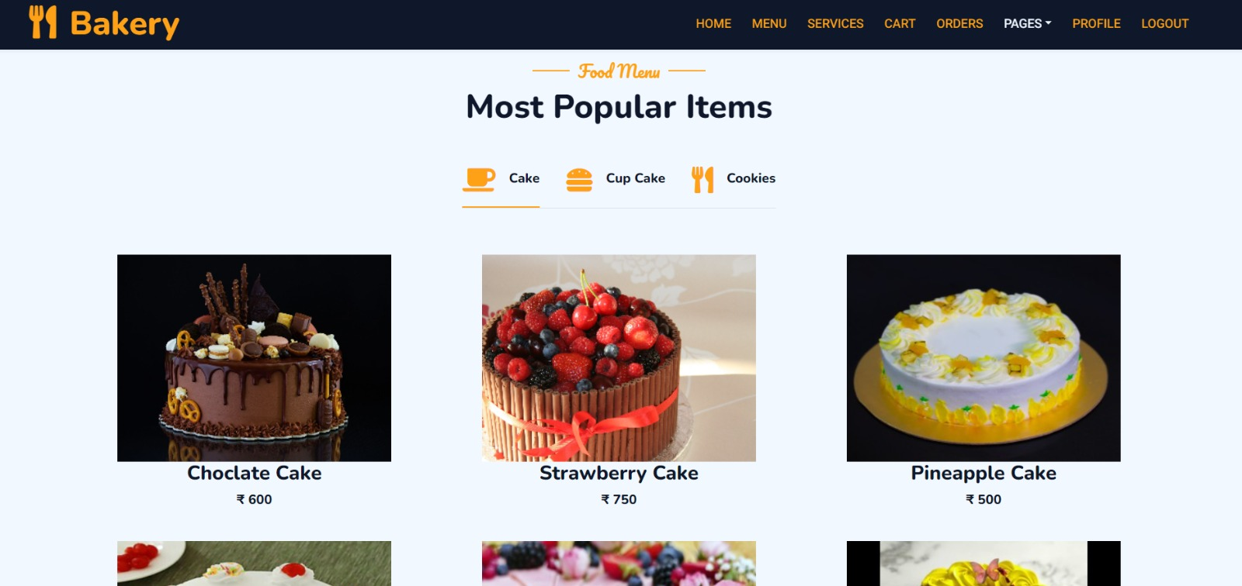

*Figure 3 Category Page*

1. **Services:**

* Customization options allow users to personalize cakes with flavors, toppings, messages, and designs.
* Delivery tracking functionality provides real-time updates on order status and estimated delivery time.

1. **Profile:**

* Users can view and update their profile information, including addresses, contact details, and saved preferences.
* Order history, wish list management, and loyalty program integration enhance user engagement.

1. **Cart:**

* The shopping cart allows users to review and modify their order before checkout.
* Calculation for taxes, discounts, and shipping costs are displayed transparently.

1. **Pages:**

* Static pages like About Us provide information about the bakery's history, values, team, and certifications.
* FAQs address common queries regarding ordering, payment, delivery, and returns.
* **Chef:**
  + A dedicated section showcases the chef's expertise, signature recipes, culinary techniques, and behind-the-scenes content.
  + Chef recommendations and featured creations add a personal touch to the user experience.
* **Review:**
  + Users can leave ratings and reviews for products, services, and overall experience.
  + Reviews are displayed prominently on product pages, influencing purchasing decisions and building trust.
* **Contact:**
  + Contact information (phone number, email, address) is easily accessible for users to reach out for inquiries, feedback, or support.
  + A contact form or live chat option provides an alternative communication channel for immediate assistance.

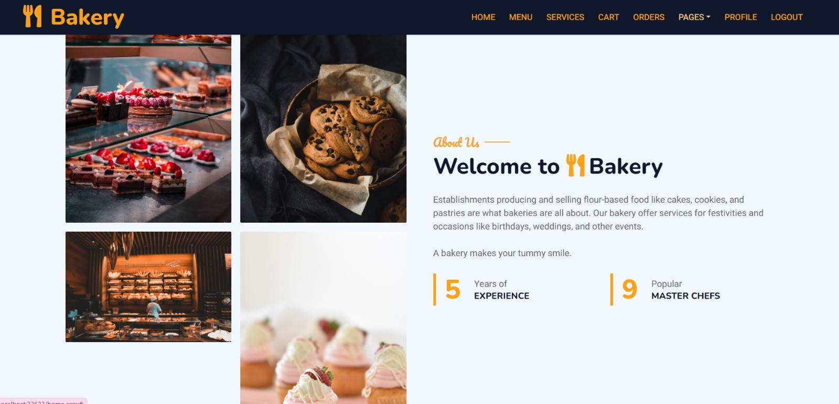

*Figure 4 About Us*

1. **Future Enhancements:**

* **Notifications:** Sending notifications to customers.
* **Expanded Product Range:** Introduce new product categories, seasonal offerings, and exclusive collaborations with local artisans or suppliers.
* **Loyalty Programs:** Implement loyalty points, referral bonuses, and special discounts for repeat customers and brand advocates.
* **Advanced Analytics:** Utilize data analytics tools to gain insights into customer behavior, sales trends, popular products, and marketing ROI.
* **Community Engagement:** Organize events, contests, and workshops to engage with the community, promote brand awareness, and gather feedback for continuous improvement.

**Technologies and Tools**

**Asp. Net**

ASP.NET, developed by Microsoft, is a robust web application framework that provides developers with a powerful platform for building dynamic and scalable web applications. It offers various features and tools that streamline the development process and enable the creation of high-performance web applications.

* **Server-Side Scripting**: ASP.NET allows developers to write server-side code using languages such as C# or VB.NET. This server-side code can interact with databases, process user input, and generate dynamic HTML content to be sent to the client's web browser.
* **Model-View-Controller (MVC) Architecture:** The MVC architectural pattern separates an application into three main components: the Model, View, and Controller. This separation of concerns promotes code organization, modularity, and maintainability. In your project, ASP.NET MVC would likely be used to handle HTTP requests, route them to appropriate controllers, process business logic in the models, and render views to display HTML content to users.
* **Integration with Visual Studio:** Visual Studio is the primary integrated development environment (IDE) for ASP.NET development. It provides developers with a comprehensive set of tools and features for writing, debugging, and deploying ASP.NET applications. Visual Studio's IntelliSense feature offers code completion, syntax highlighting, and error checking, which can significantly enhance productivity during development.

**SQL Server Management Studio (SSMS)**

SQL Server Management Studio (SSMS) is a graphical user interface tool provided by Microsoft for managing SQL Server databases. It offers a range of features for database design, administration, and maintenance.

* **Relational Database Management:** SQL Server is a powerful relational database management system (RDBMS) those stores and manages structured data. It supports SQL (Structured Query Language), which is a standard language for interacting with relational databases. In your project, SQL Server would be used to store data related to bakery products, customer orders, user accounts, and other relevant information.
* **Database Schema Design:** SSMS allows developers to design and modify the structure of a database using a graphical interface. This includes defining tables, specifying columns and data types, establishing relationships between tables, and creating indexes for optimizing query performance. A well-designed database schema forms the foundation for efficient data storage and retrieval in your application.
* **Querying and Optimization:** SSMS provides tools for writing and executing SQL queries against the database. Developers can use SQL to retrieve, manipulate, and analyze data stored in the database. SSMS also offers features for query optimization, such as query execution plans and index tuning advisors, which help identify performance bottlenecks and optimize database performance.

**Bootstrap**

Bootstrap is a popular front-end framework developed by Twitter, designed to simplify the process of creating responsive and visually appealing web interfaces.

* **Responsive Design:** Bootstrap's grid system allows developers to create responsive layouts that adapt to different screen sizes and devices. This ensures that your website looks and functions well on desktops, laptops, tablets, and smartphones, providing a consistent user experience across various platforms.
* **Predefined CSS Components:** Bootstrap includes a rich library of CSS styles and components, such as buttons, forms, navigation bars, and typography. These pre-styled components can be easily incorporated into your website, saving time and effort during development. Additionally, Bootstrap's CSS classes and utilities enable customization and styling of UI elements according to your project's requirements.
* **Customization and Theming:** Bootstrap provides tools for customizing and theming your website's appearance to align with your branding and design preferences. Developers can modify Bootstrap's variables, mixins, and components to create unique visual styles and themes for their applications. This flexibility allows you to tailor the look and feel of your online bakery website to reflect the identity and personality of your bakery brand.
* **Capabilities:** By leveraging the capabilities of ASP.NET, SQL Server Management Studio, and Bootstrap, you can build a robust and visually appealing online bakery website that meets the needs of your customers while offering a seamless user experience across different devices and platforms. These technologies provide the foundation for developing a scalable, efficient, and modern web application that showcases your bakery's products and services effectively.

**Github**

GitHub is a web-based platform used for version control and collaboration on software development projects. It provides a centralized repository for storing and managing code, enabling developers to track changes, collaborate with others, and deploy software efficiently. Here's an overview of GitHub's key features and functionalities:

* Version Control: GitHub uses Git, a distributed version control system, to track changes to files and directories within a project. Developers can create branches to work on new features or bug fixes independently, merge changes back into the main codebase, and revert to previous versions if needed.
* Repository Management: GitHub provides a platform for hosting Git repositories, called "repositories" or "repos." Each repository contains the project's source code, along with metadata such as issues, pull requests, and project documentation. Repositories can be public, allowing anyone to view and contribute to the project, or private, restricting access to authorized collaborators.
* Collaboration Tools: GitHub offers a suite of collaboration tools to facilitate communication and coordination among team members. These include:
* Pull Requests: A mechanism for proposing changes to a repository and requesting feedback from collaborators. Pull requests provide a structured way to review, discuss, and merge code changes into the main codebase.
* Code Review: GitHub provides tools for conducting code reviews, allowing collaborators to comment on specific lines of code, suggest changes, and approve or reject pull requests. Code reviews help maintain code quality, identify potential issues, and foster knowledge sharing among team members.
* Project Management: GitHub includes project management features such as project boards, milestones, and task lists to help teams organize and prioritize work. Project boards provide a visual overview of project tasks, allowing team members to track progress and manage workflow efficiently.

Overall, GitHub serves as a central hub for software development projects, providing developers with the tools and infrastructure needed to collaborate effectively, manage code changes, and deliver high-quality software products.

**Chapter 2**

**Project Implementation**

**Planning:**

Planning is a crucial phase in the software development lifecycle, laying the foundation for the successful implementation of a project. In the context of your online bakery website project, planning involves defining the system architecture, use case scenarios, and database schema to guide the development process effectively

1. **Use Case Diagram:** A use case diagram depicts the various interactions between actors (users) and the system, illustrating the different ways users can interact with the system to achieve their goals. For your online bakery website, potential actors might include:

* Customer: Represents users browsing and purchasing bakery products.
* Administrator: Represents users managing orders and inventory on the backend.
* **Use case scenarios includes:**
* Register: Customer creates a new account on the website.
* Login: Customer or administrator logs into their account.
* Browse Products: Customer navigates through the product catalog.
* Add to Cart: Customer adds items to their shopping cart.
* Checkout: Customer completes the purchase transaction by making a payment and placing the order.
* View Orders: Administrator views and manages customer orders.

The use case diagram provides a high-level overview of the system's functionality and user interactions, guiding the development of features and user interfaces.

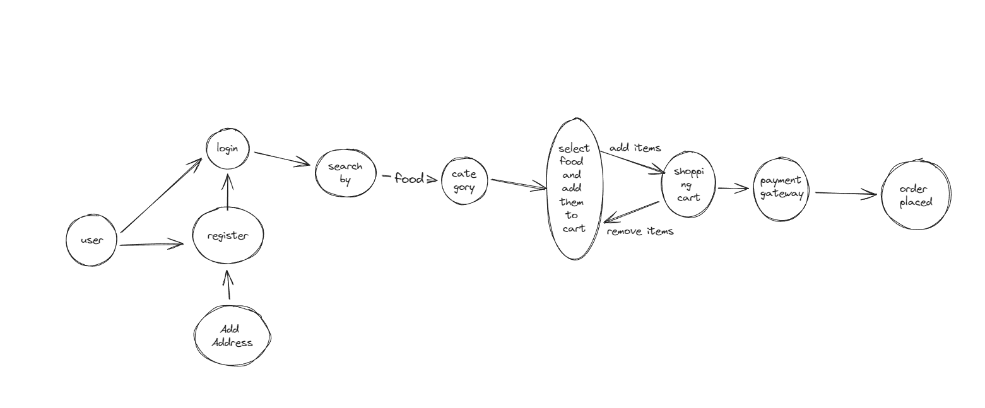

*Figure 5 Use Case Diagram*

1. **Database Schema:** The database schema presents an entity-relationship diagram (ERD) depicting the structure of the database, including tables, relationships, and attributes. Key components of the database schema might include:

* Tables: Represent entities such as products, orders, customers, and administrators.
* Relationships: Define how entities are related to each other, such as one-to-many or many-to-many relationships.
* Attributes: Specify the properties or fields of each entity, including data types, primary keys, foreign keys, and constraints.
* Indexing Strategies: Optimize database performance by indexing frequently queried fields.

The database schema serves as a blueprint for designing and implementing the database, ensuring data integrity, efficiency, and scalability.

**Development Process**

**Workflow Diagram:**

* Create a workflow diagram illustrating the development process from requirements gathering to deployment.
* Include stages such as analysis, design, coding, testing, and deployment, with milestones, deliverables, and responsible roles.

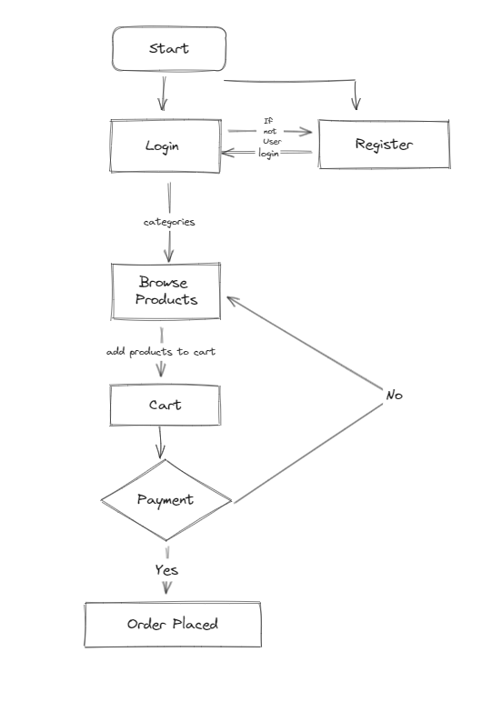

*Figure 6 Work Flow of Website*

**Development Process**:

The development process begins with a thorough analysis of project requirements. This involves gathering information from stakeholders, defining project goals and objectives, and understanding the target audience's needs and preferences. Requirements analysis lays the foundation for the subsequent stages of development by establishing clear guidelines and objectives for the project.

**Requirement Analysis:**

* Conduct thorough discussions with stakeholders to understand their requirements, goals, and target audience.
* Define the scope of the project, including key features, functionality, and design preferences.
* Identify technical requirements, such as the need for user authentication, database management, and responsive design.

**Planning and Design:**

* Create a project plan outlining tasks, timelines, and resources required for development.
* Design wireframes and mockups to visualize the layout, structure, and user interface of the website.
* Plan the database schema, defining tables, relationships, and attributes based on the data requirements of the website.

**Coding:** Implement the design using ASP.NET MVC framework, C#, HTML, CSS, JavaScript/jQuery, and Entity Framework for database interactions. Follow coding standards, design patterns (e.g., MVC, Repository pattern), and best practices for maintainable and scalable code.

**Frontend Development with Bootstrap:**

* Implement the frontend using HTML, CSS, and JavaScript, leveraging Bootstrap for responsive design and UI components.
* Utilize Bootstrap's grid system, CSS classes, and pre-designed components to create a visually appealing and mobile-friendly interface.
* Customize Bootstrap styles and components to match the branding and design requirements of the website.

**Backend Development with ASP.NET:**

* Develop the backend logic and functionality using ASP.NET, utilizing the MVC (Model-View-Controller) architecture for code organization and modularity.
* Implement controllers to handle user requests, route them to appropriate actions, and interact with the database.
* Create models to represent data entities, defining properties, relationships, and business logic.

**Database Development with SQL Server:**

* Design and create the database schema using SQL Server Management Studio or a similar tool.
* Define tables, columns, primary keys, foreign keys, and constraints based on the data model designed during the planning phase.
* Write SQL scripts to populate the database with initial data and create stored procedures for common database operations.

**Integration**:

* Integrate frontend, backend, and database components to create a cohesive and functional website.
* Conduct thorough testing, including unit testing, integration testing, and user acceptance testing.
* Test website functionality across different devices, browsers, and screen sizes to ensure compatibility and responsiveness.

**Testing:** Conduct various levels of testing throughout the development lifecycle:

* Unit Testing**:** Write unit test cases to validate individual components (e.g., controllers, services) in isolation.
* Integration Testing**:** Test the integration of components (e.g., UI with backend logic, database interactions) to ensure seamless communication and functionality.
* End-to-End Testing: Perform end-to-end testing scenarios simulating real user interactions (e.g., user registration, order processing) to validate system behavior.
* Deployment**:** Prepare for deployment by configuring web servers (e.g., IIS), setting up domain settings, implementing SSL certificates for secure connections, and monitoring deployment metrics using tools like Azure Monitor or ELK Stack.

**Database Tables**

The database schema of our website defines the structure of tables, relationships, and attributes required for data storage and management. In an ASP.NET project, SQL Server is commonly used as the backend database, and Entity Framework simplifies database interactions through code-first development.

**User Table:**

**Fields**: User ID (Primary Key), Name, Email, Password, Address, Phone, Role (Admin/User)

**Description**: The User table stores information about registered users, including their personal details, login credentials, role (admin or user), and activity timestamps.

**Product Table:**

**Fields:** Product ID (Primary Key), Name, Description, Price, Image URL, Category, Stock Quantity, Created Date, Updated Date, etc.

**Description**: The Product table holds data related to cakes available for sale, including product details, pricing, images, stock availability, category references, and timestamps for creation and updates.

**Category Table:**

**Fields:** Category ID (Primary Key), Name, Description, Created Date, Updated Date, etc.

**Description:** The Category table categorizes cakes into different types (e.g., birthday cakes, wedding cakes) for organization and navigation purposes. It includes fields for category names, descriptions, parent-child relationships, and timestamps.

**Order Table:**

**Fields:** Order ID (Primary Key), User ID (Foreign Key), Order Date, Total Amount, Status (Pending/Completed/Cancelled), Payment ID (Foreign Key), Delivery Address, Delivery Date, Remarks, etc.

**Description:** The Order table tracks customer orders, linking them to respective users and payments. It stores order details such as order date, total amount, status, delivery information, and order-specific remarks.

**Payment Table:**

**Fields:** Payment ID (Primary Key), Order ID (Foreign Key), Amount, Payment Date, Payment Method, Transaction ID, Status (Success/Failure), Card Type, Card Number, Expiry Date, Billing Address, etc.

**Description:** The Payment table records payment transactions associated with orders, including payment details like amount, payment date, method, transaction ID, status, and billing information.

**Review Table:**

**Fields:** Review ID (Primary Key), User ID (Foreign Key), Product ID (Foreign Key), Rating, Review Text, Review Date, Likes, Dislikes, etc.

**Description:** The Review table stores customer reviews and ratings for products, allowing users to share feedback, ratings, and comments. It includes fields for review details, user associations, timestamps, and interaction metrics (likes, dislikes).

The database schema's design ensures data integrity, normalization, and efficient querying for managing user information, product catalog, orders, payments, and customer feedback.

**Chapter 3**

**User Experience and Design**

**User Interface Design:**

* **Visual Elements:** This includes the design of all visual elements such as buttons, menus, images, typography, color schemes, and overall aesthetics of the website. The goal is to create a visually appealing interface that reflects the theme of your bakery and entices users to explore and order cakes.
* **Layout Design:** The layout design focuses on how different elements are arranged on each page. It involves creating a clear hierarchy of information, placing important elements prominently, and ensuring a balanced and harmonious composition. A well-designed layout enhances readability, navigation, and overall user experience.
* **Responsive Design:** With the increasing use of mobile devices, responsive design is crucial. It ensures that your website adapts seamlessly to different screen sizes and devices, providing a consistent experience across desktops, tablets, and smartphones.
* **Accessibility:** User Interface Design also considers accessibility factors such as font size, contrast ratios, keyboard navigation, and screen reader compatibility. Ensuring accessibility helps make your website usable by a wider range of users, including those with disabilities.

**UI Wireframes:**

* **Purpose:** UI wireframes are schematic representations of your website's layout and structure. They serve as a visual guide that outlines the placement of elements without focusing on design details like colors and graphics. Wireframes help in conceptualizing and refining the user interface before proceeding to the visual design phase.
* **Content and Functionality:** Wireframes specify the placement of key elements such as navigation menus, content sections, forms, buttons, and images. They also indicate functionality, such as how users interact with different elements (e.g., clicking a button to add a cake to the cart).
* **Feedback and Iteration:** UI wireframes are often used to gather feedback from stakeholders and users early in the design process. This feedback loop allows for iterative improvements and ensures that the final design meets user expectations and business objectives.
* **Collaboration:** Wireframes facilitate collaboration between designers, developers, and stakeholders by providing a common understanding of the website's structure and functionality. They act as a blueprint that guides the development process and reduces misunderstandings during implementation.

**User Journey Map:**

* **Definition:** A User Journey Map is a visual representation of the steps a user takes from their initial interaction with your website (landing on the homepage) to accomplishing a specific goal (completing a cake order). It outlines the various touch points, interactions, decision-making moments, and emotions that users experience throughout their journey.

**Key Components:**

* **Entry Point:** This is where users first land on your website, such as the homepage or a specific landing page.
* **Interactions:** User interactions include actions like browsing cake categories, selecting a cake, customizing the order, adding to cart, and proceeding to checkout.
* **Decision Points:** These are moments where users make choices, such as selecting cake flavors, choosing delivery options, or deciding whether to create an account.
* **Feedback and Support:** User journey maps may also include elements related to feedback mechanisms (like reviews or ratings) and support options (such as live chat or FAQs) that users can access during their journey.
* **Completion:** The journey culminates in the successful completion of the cake order and any post-order interactions like order confirmation and tracking.

**Chapter 4**

**Challenges and Learning**

**Technological Challenges and Solutions**

**Challenges Faced:**

* **Scalability:** One of the challenges faced in online cake delivery websites is scalability, especially during peak seasons or promotional events when there's a surge in orders and website traffic.
* **Real-time Order Processing**: Ensuring real-time order processing, inventory management, and delivery tracking to provide a seamless customer experience.
* **Security:** Managing sensitive customer data (e.g., personal information, payment details) securely to prevent data breaches and ensure compliance with data protection regulations (e.g., GDPR, PCI DSS).
* **Integration Complexity:** Integrating external services like payment gateways, shipping carriers, and third-party APIs while maintaining system stability and performance.

**Solutions Implemented:**

* **Scalability Solutions:** Implemented horizontal scaling by deploying the application across multiple servers (load balancing) to handle increased traffic and concurrent user requests. Utilized caching mechanisms (e.g., Redis, in-memory caching) for faster data retrieval and reduced server load.
* **Real-time Order Processing:** Utilized messaging queues (e.g., RabbitMQ, Azure Service Bus) and event-driven architecture to process orders in real-time, update inventory status, and trigger notifications to customers and delivery personnel.
* **Security Measures:** Implemented encryption techniques (e.g., HTTPS/TLS for secure communication, data encryption at rest using AES) to protect sensitive data. Implemented strict access controls, authentication, and authorization mechanisms (e.g., JWT tokens, role-based access control) to secure APIs and backend systems.
* **Integration Solutions:** Utilized API gateways and middleware services (e.g., Azure API Management, Kong) for seamless integration with external services. Implemented retry mechanisms, error handling, and asynchronous processing to handle integration failures gracefully without impacting user experience.

**Performance Optimization:**

* **Performance Monitoring:** Implemented performance monitoring tools (e.g., Application Insights, New Relic) to track key performance metrics such as response time, throughput, CPU utilization, memory usage, and database query performance.
* **Code Optimization:** Conducted code reviews and performance profiling to identify and optimize performance bottlenecks (e.g., inefficient database queries, resource-intensive operations). Utilized techniques like lazy loading, eager loading, and query optimization to improve data retrieval efficiency.
* **Caching Strategies:** Implemented caching strategies at various levels (e.g., client-side caching using browser cache, server-side caching using Redis/Memcached) to cache static content, frequently accessed data, and session data. Utilized caching headers (e.g., Cache-Control, Expires) for cache control and invalidation strategies.
* **Database Optimization:** Optimized database performance by indexing frequently queried columns, tuning database queries, minimizing database round-trips, and implementing database shredding/partitioning for large datasets. Utilized tools like SQL Server Profiler and Execution Plans for query optimization.
* **Content Delivery Network (CDN):** Leveraged CDN services (e.g., Azure CDN, Cloudflare) to distribute static assets (e.g., images, CSS, JavaScript) globally, reducing latency and improving content delivery speed for users across different geographic regions.

**Key Takeaways:**

* **Understanding Customer Needs:** Through the project, gained insights into customer preferences, behavior, and expectations regarding online cake ordering. This understanding helped in designing user-centric features and enhancing customer satisfaction.
* **Technology Stack Mastery:** Developed proficiency in ASP.NET MVC framework, Entity Framework for database interactions, front-end technologies like HTML/CSS/JavaScript, and integration of external services (e.g., payment gateways, email services). Acquired knowledge of best practices and patterns in web development.
* **Business Operations Understanding:** Explored various aspects of running an online cake delivery business, including inventory management, order processing, payment handling, customer support, and marketing strategies. This hands-on experience provided valuable insights into business operations and logistics.
* **Project Management Skills:** Learned project management methodologies, task prioritization, timeline management, collaboration with team members, and handling project challenges. Improved communication, coordination, and decision-making skills.

**Chapter 5**

**Conclusion & Bibliography**

**In conclusion**, the development of the online cake delivery website using ASP.NET has been a valuable learning experience, providing insights into customer needs, technology stack mastery, business operations understanding, and project management skills. Through this project, several key takeaways and lessons learned have been identified, paving the way for implementing best practices in web development, security, performance optimization, and customer engagement.

**Project Achievements:** The project has achieved the following milestones and accomplishments:

* **Successful Implementation:** Successfully implemented an online cake delivery platform using ASP.NET MVC framework, Entity Framework for database interactions, and integrated external services like payment gateways and email services.
* **Enhanced User Experience:** Designed a user-friendly interface with intuitive navigation, responsive design, clear product information, and seamless checkout processes, enhancing the overall user experience.
* **Robust Security Measures:** Implemented robust security measures, including secure authentication, data encryption, input validation, and protection against common vulnerabilities, ensuring customer data security and compliance.
* **Performance Optimization:** Optimized website performance by reducing load times, minimizing server requests, optimizing images and assets, implementing caching strategies, and leveraging content delivery networks (CDNs) for faster content delivery.
* **Agile Development Practices:** Embraced agile methodologies for iterative development, rapid prototyping, continuous integration, and delivery, fostering collaboration, communication, and transparency within the development team.

**Future Roadmap:**

Looking ahead, the future roadmap for the online cake delivery website includes the following initiatives:

* Feature Enhancements: Continuously enhancefeatures such as personalized recommendations, order tracking, multi-language support, social media integration, and notification sending to improve user engagement and satisfaction.
* Mobile App Development: Explore the development of a mobile app for iOS and Android platforms to reach a wider audience and provide a seamless mobile experience for customers.
* AI and Analytics Integration**:** Integrate artificial intelligence (AI) capabilities for predictive analytics, customer behavior analysis, personalized recommendations, and automated customer support to enhance decision-making and customer interactions.
* Expansion and Partnerships**:** Explore opportunities for business expansion, partnerships with local bakeries, event planners, and catering services to offer a wider range of products and services to customers.
* Continuous Improvement**:** Adopt a culture of continuous improvement, feedback collection, performance monitoring, and data-driven decision-making to stay competitive, innovate, and meet evolving customer expectations.

By focusing on these initiatives, the online cake delivery website can continue to grow, innovate, and deliver exceptional value to customers, driving business success and market leadership in the online cake delivery industry. This conclusion summarizes the achievements, lessons learned, and future roadmap for your online cake delivery website project using ASP.NET

**BIBLIOGRAPHY**

* The Bread Baker's Guild of America - https://www.bbga.org/
* King Arthur Baking- https://www.kingarthurbaking.com/
* Back DoorDonuts - https://www.backdoordonuts.com/